Steps for testing the scope logic

On KMS portal:
1) Setup up the KMS with the scope and update the description field
Ex: For PROFILE scope, following is the description field value,

PROFILE,CP1,CP2,CP3,CP4,CP6,CP7,CP8,CP9,CP10,CP11,CP12,CP13,CP14,CP15,CP16,CP17,CP18,CP19,CP20,CP21,CP22,CP23,CP24,CP25,CP26,CP27,CP28,CP29,CP31,CP32,CP33,R1-Cart-Validate,R4-Price-The-Cart,R5-Check-Out-The-Cart

For RENTALHISTORY, following is the description,

RENTALHISTORY,CP5
2) Associate the scope with a particular API key
On Client Side when issuing a request:
1) Generate a token using that particular key
2) Issue a request, using the generated token
On Application Side when request is received by gateway:
1) Once the request is received, extract the passed in scopes from the token (Access Token Validation)
2) Collect the scopes supported, by the apiKey used (Client key validation)
3) Collect the description of the scopes passed in with the token (JavaCallout)
4) Check whether, the current operation falls within the ambit of the passed in scope (Python script)
5) Allow if supported, 401 if not supported (Python script)

Steps for enabling scope logic on an Application (applies only for Customers and Reservations):
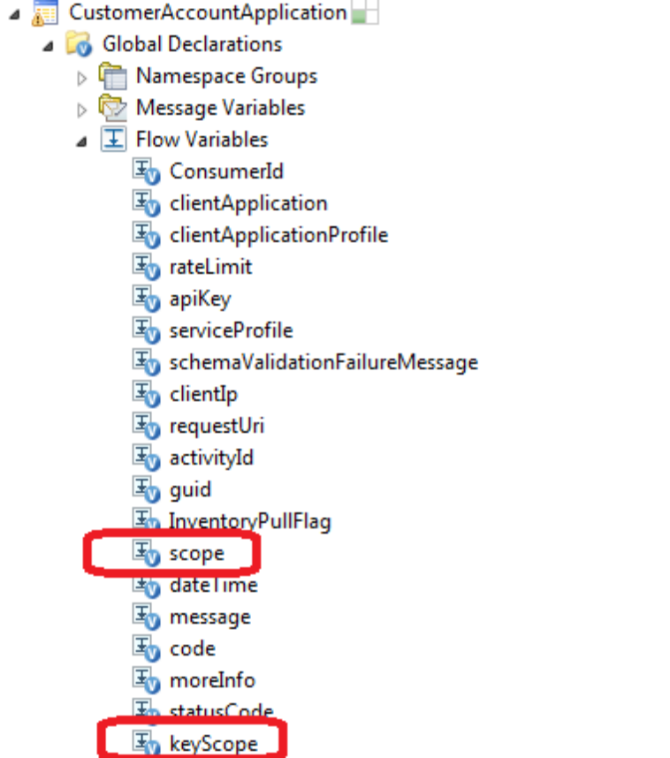Add Flow Variables
- Add flow variables keyScope and scope at the application level

- Collect the key scope values in the policy ClientKeyValidationPolicy. In the validateClientId service callout, on Response, set value of adminScopeXPath to the keyScope variable

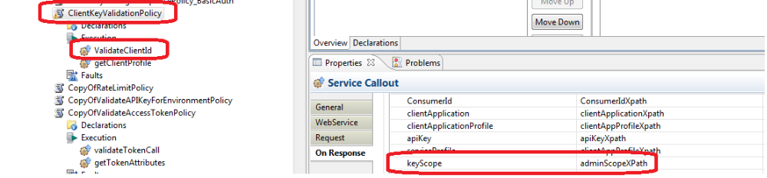Set value of keyScope variable in ClientValidationPolicy

- Collect the token scope value in the policy ValidateAccessTokenPolicy. In the getTokenAttributes service callout, on Response, sett value of scopeXPath to the scope variable

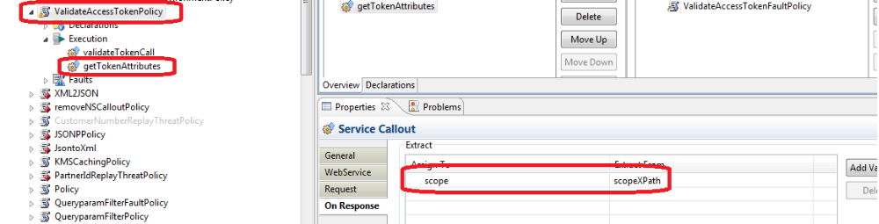Set the scope variable in ValidateAccessTokenPolicy

- Add the RetrieveScopeDescriptionPolicy, at the application level. This contains the JAR to retrieve the scope description for the selected scopes. Attach this policy at the Client Request endpoint, after ClientValidationPolicy and ValidateAccessTokenPolicy. Make sure the Configuration variables KMS_URL and AUTH are set appropriately. KMS_URL contains the URL of the KMS API. AUTH contains the basic authentication string for the same.

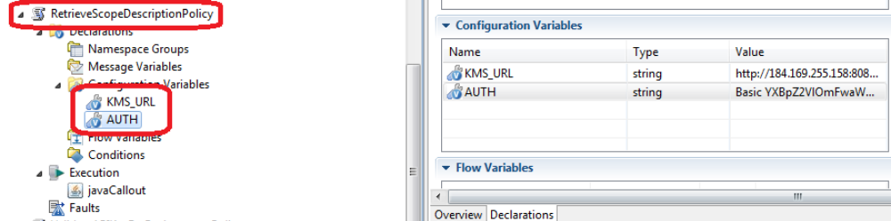Add and attach RetrieveScopeDescriptionPolicy

- Add the ValidateScopePolicy at the application level. This contains the Jython script required for validating whether the current operation lies within the token scope. Attach this, at the operation level, for every operation, that requires scoped protection. Ex: CP1, CP2 etc. Following is the script for this policy:

ValidateScope.py
#scope check method
def check(scopeArray, passedScopeArray, opName):
for scope in scopeArray:
for passedScope in passedScopeArray:
if passedScope in scope:
scopeOps = scope.split(",")
#remove the first entry, since its the scope name itself
scopeOps.pop(0)
if opName in scopeOps:
return "true"

#input params
passedScopeString = messageContext.variables['scope']
opName = messageContext.variables['_clientendpoint.operationname']
scopeString = messageContext.variables['keyScope']

passedScopeArray = passedScopeString.split(" ")
scopeArray = scopeString.split(" ")

#check whether in scope or not
if check(scopeArray, passedScopeArray, opName) == "true":
messageContext.variables['isInScope'] = "true"
else:
messageContext.variables['isInScope'] = "false"

#is no scopes passed in
if passedScopeString == "":
messageContext.variables['isInScope'] = "false"

